Observational Problem
Main Telescope
- Point your telescope to NGC 6475
RA (J2000): 17h 53m 54s
Dec (J2000): -34º 49”
Validate your object to your telescope assistant. (20 Point)

- Write down the cardinal direction (North, South, East and West) on Chart 1 in the answer sheet. (10 Point)

- Find 3 missing stars on Chart 1 based on the object you have observed. Mark the position of the missing stars with crosses (X). (25 Point)

- Given that the magnitude of star A, B and C are 7.6, 7.2, and 5.6 respectively. Estimate and write down the magnitude of the missing stars beside each mark you have given. (20 Point)

- Estimate the FOV of the eyepiece in this observation, stopwatch provided. Show your calculation in the answer sheet. (25 Point)

Anwer Sheet

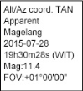
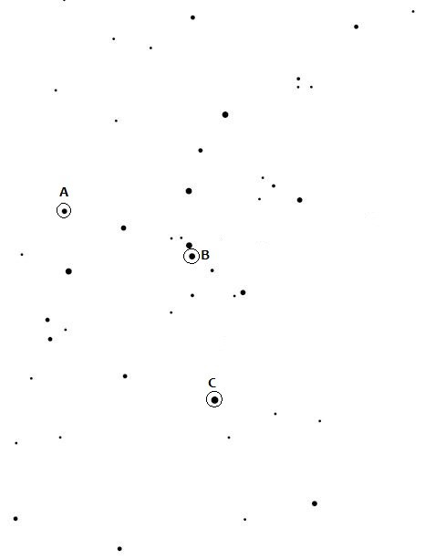
Chart 1

Solution,
1. Checklist: (Telescope Assistant)
- Object Accuracy (Right Object = Full Score).

Answer
No 2 (Cardinal Point) Each Correct Cardinal Point (Quarter Score)
No 3 (three missing stars) Region 1 (Full Score), 2 (Half Score), 3 (Quarter Score)
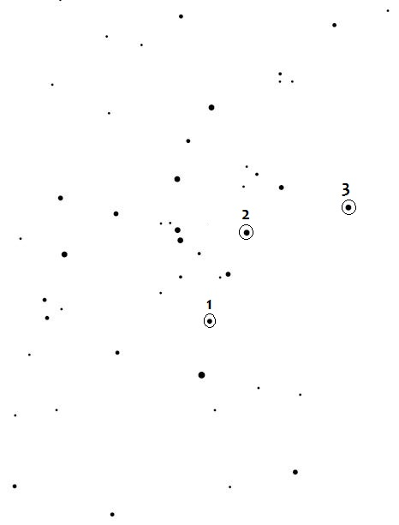
Note: The region are marked with the circles (region will be chosen during the IBM)
S
N
W
E

4. Missing Stars: 1. 7.4
2. 6.4
3. 7.0

Score Range:
±0.2 = Full Score
±0.5 = Half Score
±0.8 = Quarter Score

- Using the 15mm (eyepiece), the field of view of the instrument is: 0.75º
- Using stopwatch to measure the time for a star to travel from the center of the FOV to the edge of the FOV. (Half Score)
- Using stopwatch to measure the time for a star to travel from the edge of the FOV to the other edge of the FOV (Quarter Score)
- Calculating the FOV,
$$FOV\left(deg\right)=\frac{Travel time\left(sec\right)}{23h 56m}xcos(δ)x360deg$$
(Half Score)

